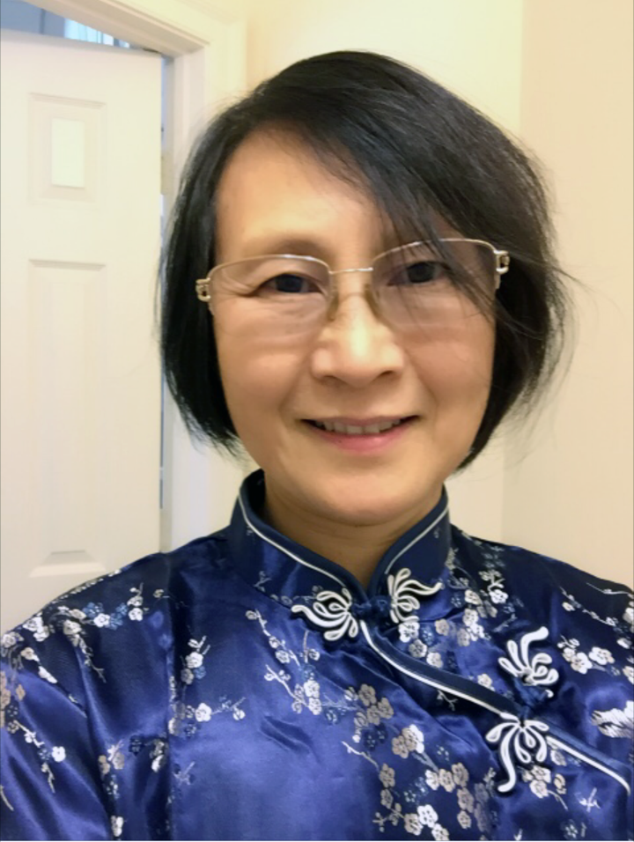

萧偉生于中国，1985年来美求学。自幼喜欢书法、绘画，1997年重拾画笔。她是美国墨绘协会和中华文化艺术同盟会会员。十年来跟随靳杰强，Freda 李等老师学习国画和书法。近一年又拜张明明老师学习水彩, 学习西方美术透视及色彩技法。曾多次参加美国墨绘协会在马里兰州和加拿大的书法和绘画展出，和其它书法和绘画展出。

Ms. Wei Xiao， born in China，came to the United States for graduate study in early 1985. She is a member of the Sumi-e Society of America, Inc., and The Chinese Culture and Art League.

Ms. Xiao has been learning and practicing calligraphy and painting since childhood. She pick up Chinese calligraphy and brush painting in 1997 in the USA. Ms. Xiao continued the study of Chinese painting and calligraphy under Kit Keung Kan, and Freda Lee-McCann for more than 10 years. In addition to Chinese calligraphy and brush painting, she recently started to paint in watercolor and western watercolor from her teacher Ming Ming Zheng. She has attended a number of the Sumi-e show in Maryland and Canada. She has attended other exhibits in the field of calligraphy and brush painting in Maryland.